**Email #1**

***Subject 1****: Oriental Blue Tonic Melts 63 pounds of fat*

***Subject 2****: Weird Blue Tonic Melts Fat Overnight*

This bizarre Blue Tonic is the talk of Tik Tok with scores of users crediting it for their weight loss success.

By simply mixing with water and taking before bed a 46 year old mom of 3 from Kansas was able to liquify 63 pounds of stubborn fat from her hips, arms, belly and thighs that had plagued her for so long.

Visit the link below to find out all about it.

**[This oriental blue tonic melts fat overnight](http://www.google.com/)**

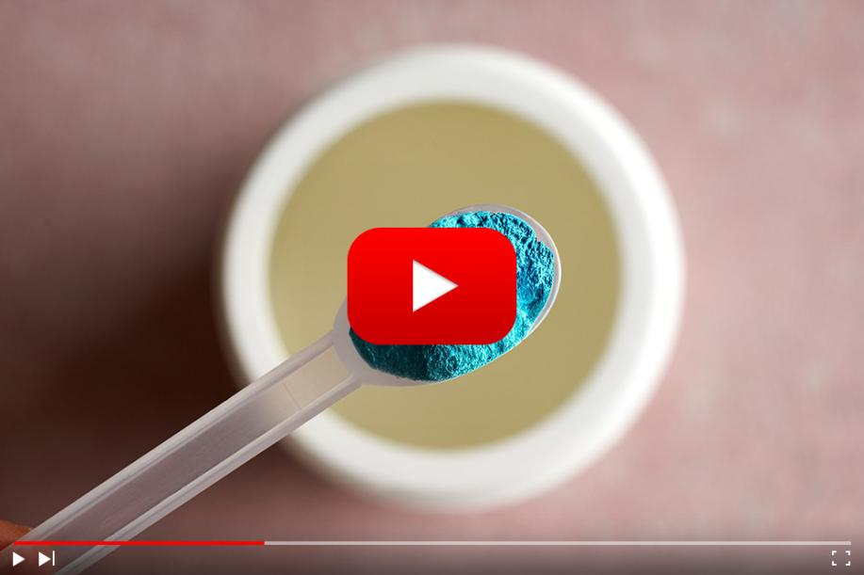

**Email #2**

***Subject 1****: 95% of participants lost at least 25 pounds…*

***Subject 2****:* *Bizarre Blue Liquid Erases Fat Cells Overnight*

An Indonesian scientist has revealed the real root cause of your stubborn belly fat and it’s NOT what you think…

95% of trial participants lost at least 25 pounds with this bizarre Blue Tonic ritual and the average weight loss in the group was 53 pounds.

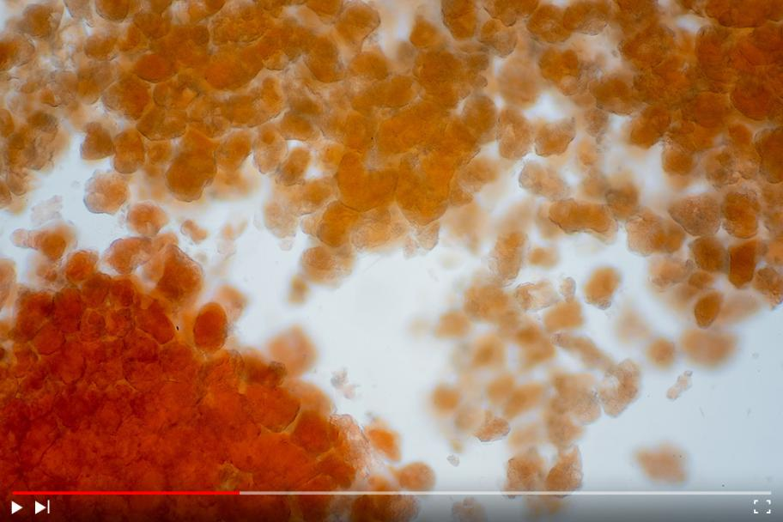

Try this for yourself tonight..

[➔](http://www.google.com/) **[Oriental Blue Tonic Melts Fat As you Sleep.](http://www.google.com/)**

Stop wasting time with fad diets and workout plans! Simply take one scoop of the blue tonic before bed and watch as the fat melts away by morning.

{insert your name}

page5image59955088

**Email #3**

***Subject 1****: How Was a 46 year old mom of 3 able to melt away 63 pounds of fat.*

***Subject 2:*** *mom of 3 from Kansas, liquifies 63 pounds of Fat with blue tonic*

After countless failed diets and exercise plans a 46 year old mom of 3 from Kansas was finally able to dissolve 63 pounds of stubborn fat that had plagued her for so long..

Without working out, without dieting and all while still enjoying all her favourite foods.

[➔](http://www.google.com/) **[Click Here To Find Out How](http://www.google.com/)**

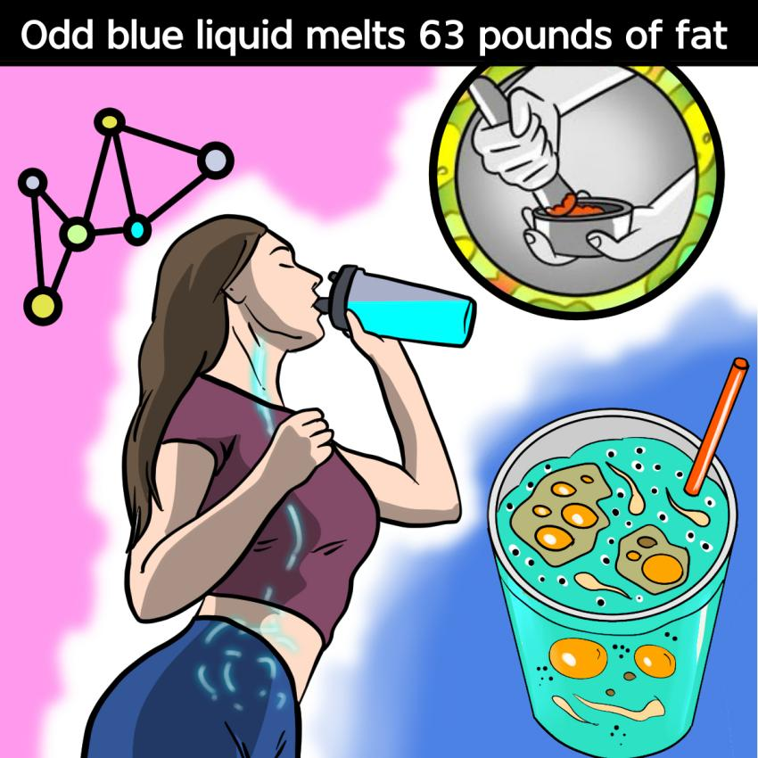

**Email #4**

***Subject 1****: mom of 3 melts fat overnight with odd recipe.*

***Subject 2****: Bizarre recipe Melts Fat overnight*

Scientists have revealed a little known recipe that when taken at night can increase fat burning by up to 247%

Can you guess what’s in this odd fat melting recipe?

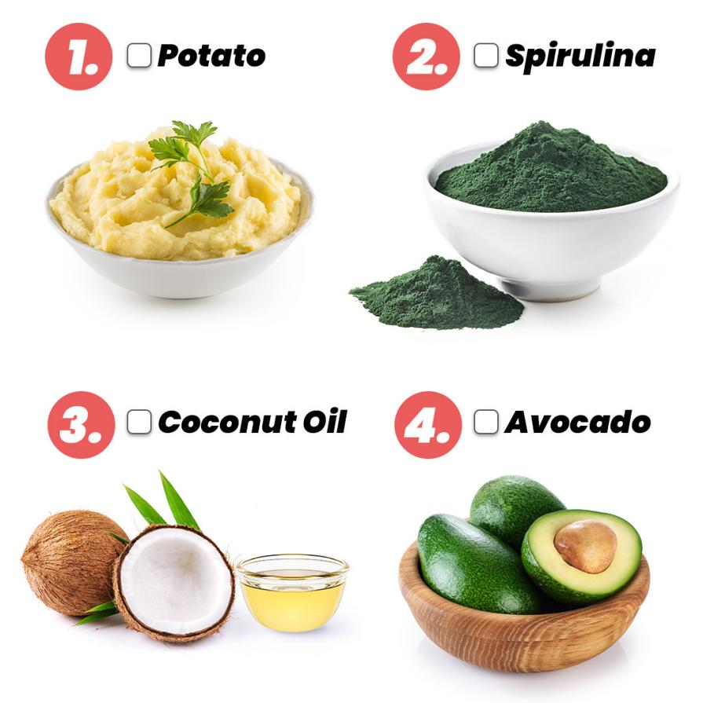

1. Potato
2. Spirulina
3. Coconut Oil
4. Avocado

Thousands of people are already using this bizarre recipe to transform their bodies overnight and drop at least 25 pounds.

**[To find out this fat liquifying recipe for yourself, watch this short video here.](http://www.google.com/)**

page7image60005280

**Email #5**

***Subject 1****: Oriental Blue Tonic Melts 63 pounds Of Stubborn Fat*

***Subject 2:*** *Odd Blue Tonic Erases Belly Fat*

This simple night time weight loss hack was tested with a group of volunteers all suffering from varying levels of obesity

After ninety days the results were more incredible than anyone could have ever imagined…



On average they lost 53 pounds of fat...

They experienced increased energy…

Better mood…

Enhanced sex drive and performance…

Several of them could even see their abs for the first time ever…

This simple night time hack had actually worked on everyone!

Regardless of how much they had to lose… Their metabolism… Their genetics… or their age.

**[==> Click Here To Learn More](http://www.google.com/)**

P.S This presentation may not be up for long so make sure to check it out before it's removed.

page9image60214112page9image60214736